Newsletter
Issue 5

6 October 2023

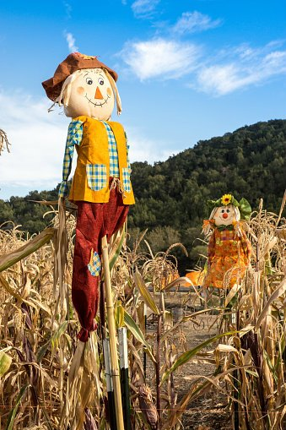
Dear Parents and Carers

We are very pleased to announce that Sarah McDowall who works in our Nursery Class has successfully passed her Level 3 Early Years Practitioner exams with distinction – well done Sarah we are all very proud of her!

Please find attached a flyer on how to report Anti-social behaviour in our community. These reports can be done anonymously. The safe4me website has a professionals link too.
https://www.safe4me.co.uk/

Girls Football
Our Girls Football Team played their first match of the season yesterday, away at Western CE Primary School. We had a good lunchtime training session before the game where we focused on formations and passing so we went into the game full of confidence. However, we came up against an extremely strong team which meant we finished on the losing side. Our Girls Team never game up and battled well right to the end and were complimented by all the staff at Western on their resilience.

Our Boys Team’s play their first fixtures next week and our Girls Team is looking forward to playing their first home fixture in the week before half term.

Ms Langridge and Mr Sleeman

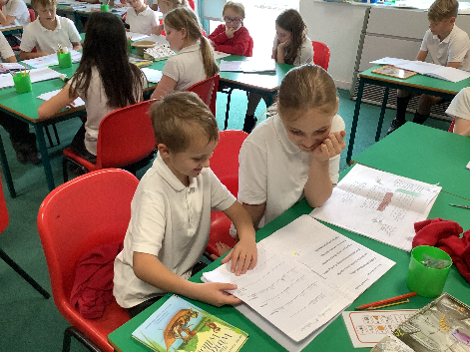
Year 4 and Year 6
Year 4 and Year 6 have been sharing poems and reports about the story of The Peppered Moth.

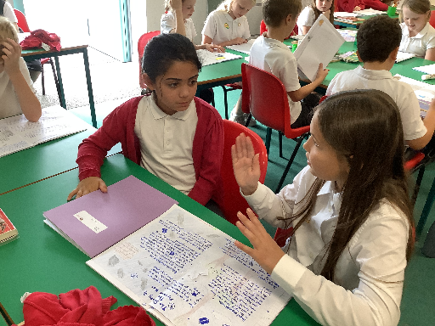

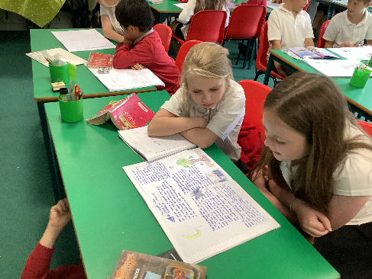

Parents Evenings
A reminder that Parents evenings for Year R – 6 will be taking place next week. The sign- up sheets will be in the hall at the start and end of the school day. This is a good opportunity to find out how your child/ren are settling into the new school year. Please telephone the school office if you would like a member of our admin team to book one for you.

School Photographer
Date for your diary – the school photographer will be in school on Thursday 16 November to take individual and sibling pictures. The orders will be ready in time for Christmas.

Flu Immunisations
The school nursing team will be in school on Tuesday 5 December to deliver the flu vaccinations to all children in Year R through to Year 6.

A separate parentmail has been sent out this week to enable you to sign up if you would like your child to receive the vaccination.

New Menu
A new menu has been sent home this week which will commence after half term. The kitchen are also offering the children a Jacket Potatoes option. If you would like a paper copy of the menus please contact the school office.

Lunch Club
The Little Lunch Club will be providing free freshly made children’s lunches during the October half term. These are available for school-aged children living in Winchester City and District and are in receipt of free school meals. Also available for families who are worried about affording food for their children during half term.

Please see the attached leaflet for more information.

Year R School Applications
If your child is four, or will turn four before 1 September 2024, they can start school in September 2024. For more information go to www.hants.gov.uk/admissions Applications are open from 1 November 2023 and will close on Monday 15 January 2024.

Secondary School Applications
Secondary School place applications for September 2024 are now open and will close on Tuesday 31 October 2023. Parents and Carers with children due to move to secondary school next year can now apply for their child’s school place. Applications can be submitted online or paper forms can be requested by emailing admissions.team@hants.gov.uk.

Halloween Disco
Date for your diary – the PTA have organised a Halloween Disco, taking place on Thursday 19 October. KS1 and Nursery from 5pm – 6pm and KS2 from 6.30pm – 7.30pm. Prizes for best homemade costumes. The cost is £3.00 per entry which includes drinks, sweets and games. Please note Parent/Carers must stay with Nursery Children.
Learning Behaviours
We have held this week’s Learning Behaviours assembly. This is where each teacher chooses a child/children that has demonstrated the chosen learning behaviour of the week. The teacher shares with everyone what the child has done and then we all celebrate their achievement. This term we are looking at respect. The children who were chosen this week were:

Year One Evelyn T

Year Two Danny W

Year Three Liam G

Year Four Olivia R

Year Five Athmika N and Noah Z

Year Six Charlie J

School Lunches
Thank you to everyone for settling their lunch accounts, however the lunch debts are still high - please could you ensure that your account is kept up to date. For your information the money owed per class is as follows:-

Hares £ 127.33
Foxes £ 22.95
Herons £ 161.50
Kingfishers £ 161.60
Nursery £ 34.60

From Monday 18 September your child will not be able to order a school lunch if the debt is above £10.00 – if the debt is over £10.00 they will need to bring in a packed lunch. Please can you arrange to clear your Lunch accounts before as soon as possible.

If you would like an up to date statement of your child’s account please contact the Admin Team. If you have not yet registered to pay online via Scopay and would like a copy of your login details please email us and we will be happy to help. We would appreciate it if all accounts, including any outstanding Breakfast Club and After School Club accounts, could be settled as soon as possible. Please ensure that your After School Club Account is up to date as we employ extra staff for this club. If you would like an up to date statement please contact the school office.

Thank you for your continued support.

Yours faithfully

Mrs Bordoli
Interim Headteacher

Dates for your diary (new dates in red)
Open Morning (9.30am) 19 October 2023
Halloween Disco 19 October 2023
Inset Day 20 October 2023
Secondary School Applications close 31 October 2023
School Photographer 16 November 2023
Open Morning (9.30am) 29 November 2023
Flu Vaccinations 5 December 2023
Whole School Trip to Cinderella 14 December 2023
School breaks up for Christmas 15 December 2023
School returns for Spring term 2 January 2024
Open Morning (9.30am) 5 January 2024
Year R school applications close 15 January 2024
Inset Day 19 February 2024
Inset Day 28 June 2024
Inset Day 1 July 2024

